

**Computer Networks Lab 10**



**Name:Muhammad Shaheer.**

**Roll No:20p-0480**

NATIONAL UNIVERSTIY OF COMPUTER AND EMERGING SCIENCES, FAST- PESHAWAR CAMPUS Department of Computer Science & Software Engineering

Task 1: Inspect the three-way handshake and answer the following questions:

1. What is the source and destination port numbers?

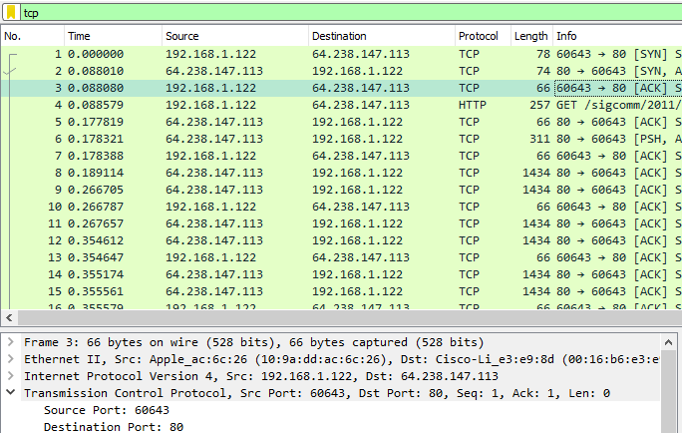

2. What is the sequence number of the TCP SYN segment that is used to initiate

the TCP connection? What is it in the segment that identifies the segment as

a SYN segment?

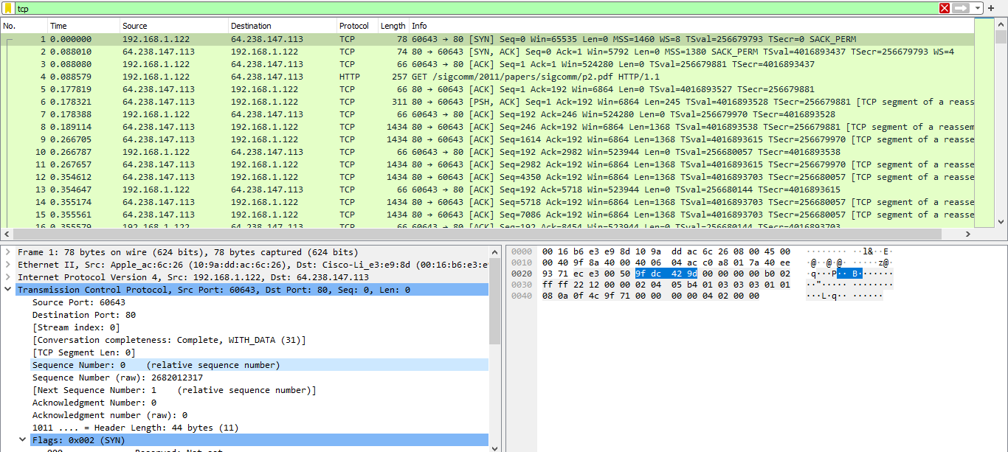

3. What is the sequence number of the SYNACK segment sent by the server to

the client computer in reply to the SYN? What is the value of the

Acknowledgement field in the SYNACK segment? How did server determine

that value? What is it in the segment that identifies the segment as a SYNACK

segment?

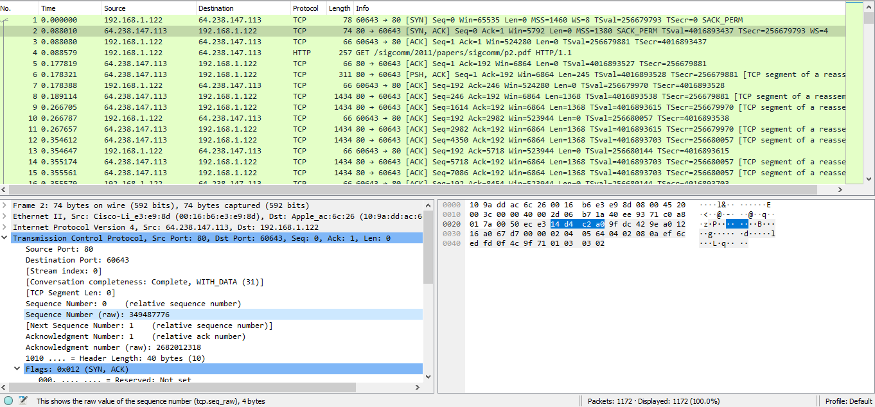

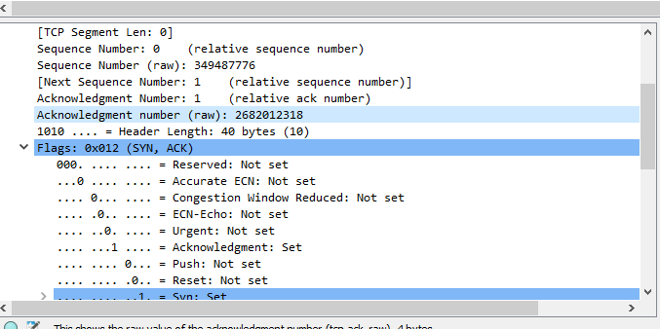

4. What is the length of each of the first six TCP segments?

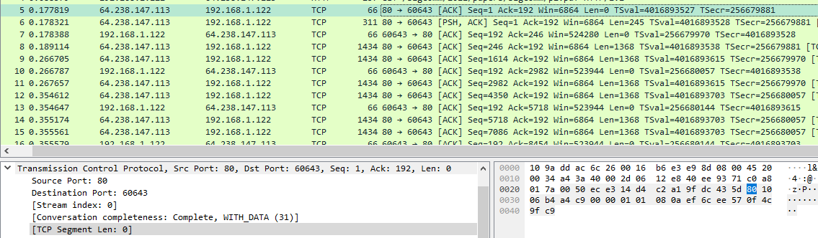

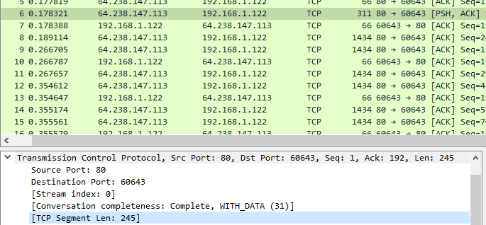

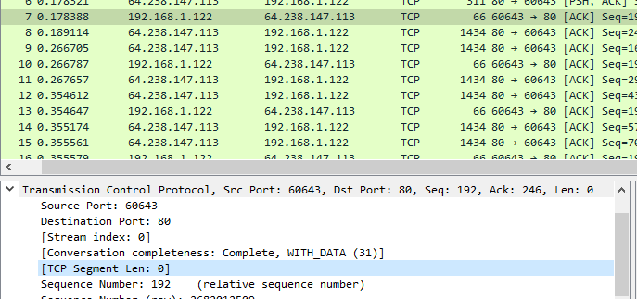

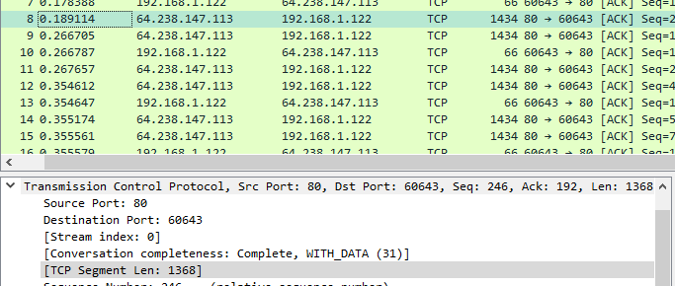

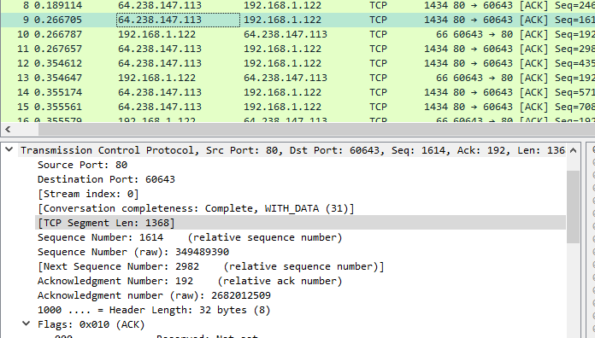

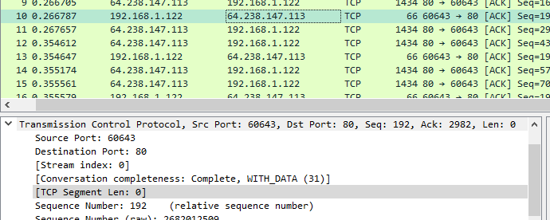

5. Are there any retransmitted segments in the trace file? What did you check

for (in the trace) in order to answer this question?

Ans:

No